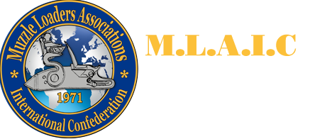

Information booklet of the 1st MLAIC World Cup
1st – 7th August 2022
Szentendre-Izbég, Hungary
Version: 2022.03.03.
Table of contents
Official Invitation to the 1st MLAIC Long Range World Cup 2
General information about the World Cup 3
Location: 3
Information about firearms laws in Hungary: 3
Disciplines: 3
Target sizes: 3
The camera system: 4
Maximum number of shooters: 4
Costs: 4
The organizing committee: 4
Registration information and dates 5
Deadlines 5
Bank data of the Hungarian Blackpowder Shooters and Hunters Association: 5
Shooting range information 5
Preliminary competition program 6
Protocol for using camera systems on MLAIC long range competitions 7
Why digital camera system? 7
How to integrate the use of digital camera system into the system of LRML? 7
Important safety rules 10
Travel and accommodation information 11

Official Invitation to the 1st MLAIC Long Range World Cup

Dear Delegates, Team Captains, dear Long Range Shooters of the World,
On behalf of Hungarian Blackpowder Shooters and Hunters Association and the Muzzleloaders Associations International Confederation, it is our pleasure to extend the invitation to the 1st MLAIC Long Range World Cup from 1st – 7th August 2022 as part of the 50th Anniversary Shooting festival of MLAIC.
This event will be a special event from many sides. First of all, this is the first ever MLAIC long range international competition to be held in eastern-central Europe, it is also the first ever MLAIC Long Range World Cup, and finally this will be the first international competition to be shot entirely on state-of-the-art camera systems.
The Hungarian organizers, supported by the MLAIC Long Range Committee worked hard in the past year to overcome the challenges of Covid and in the meantime develop the proper protocol for running a long range competition on camera system. Wea are happy to announce that the protocol is ready and the camera systems were well tested in different shooting conditions.
The event will take place in the beautiful, picturesque village of Szentendre, close to Budapest, at the military shooting range of Izbég. This location not only serves the competition well, but also offers an excellent possibility for shooters and family members to immerse in the beauty and history of our little central European country.
Official web-page of the event: https://mlaic.org
Facebook page of the event: https://www.facebook.com/MLAICChamps
Official email of the event: registration@meflsz.hu
Match Director: Gerda Lejeune
Head of the organizing committee: Balázs Németh
It would be our honor to have your national team's presence on this auspicious occasion.
We do hope that you will be able to confirm your attendance to this invitation; we look forward to your presence at this celebration of historical shooting sports.
If you have any questions, please do not hesitate to contact us.
See you in Hungary!
Yours Sincerely,

Pál Törőcsik Balázs Németh
Chairman Head of the organizing committee

General information about the World Cup

Location:
The competition will be shot at the military shooting range of Izbég, close to the village of Szentendre. The range is located at a distance of 10-minute drive from the historic center of Szentendre, and 30-minute drive from the center of Budapest.
Coordinates of the military shooting range at Izbég: 47.69776307535956, 19.016162487806092
https://www.google.com/maps/@47.6963994,19.0177555,1198m/data=!3m1!1e3

Information about firearms laws in Hungary:
All muzzle loading arms are free in Hungary, and they are free for private import as well. Therefore, no license is needed to enter the country with muzzle loading arms. However, to ease customs procedures for participants arriving by plane, the individual entry forms will be returned to the competitors signed by our association. We will also notify the customs offices at the Liszt Ferenc Budapest Airport about the arrival of the national teams.
Black powder and percussion caps are licensed in Hungary. They can only be purchased by licensed personnel; they cannot be imported into the country by private persons. The powder and caps ordered by the national teams will be handed over by the Hungarian organization to the teams at the shooting range upon arrival.

Disciplines:
All disciplines will be shot on the yard system. Team events will be calculated using the scores shot in individual competitions (team events will not be shot separately). This decision can be overruled on basis of the number of preliminary individual registrations. Both original and replica class will be held during the World Cup. One shooter can register in either replica or original class.

Target sizes:
The competition will be shot on yard basis, using the corresponding target sizes. The only difference will be on 900 and 1000 yards, where the total height of the target will be 60” instead of 70” due to the field of view of the camera system. All other parameters of the targets will be as they are described in the MLAIC Rule Book 7.9 section.

The camera system:
The camera system used for the competition will be the Long Shot LR-3 system. The HBSHA is in possession of 7 cameras and receivers, and 4 more will be arriving soon. The scores will be convenient to follow on any iOS or Android tablet or smart phone. Tablets will be provided by the HBSHA to the scorers, but we suggest the shooters to bring their smart phones/tablets as well, as they will have access to the WLAN system of the cameras. We also suggest to equip power banks for the smart phones and tablets, as using the application drains the battery of a normal phone in 4-6 hour time. The application is capable of tracking shots of 5 individual shooters and flash the last successful shot on the target. Each camera and receiver will serve 2 shooters simultaneously. Detailed user’s manual will be provided later by the HBSHA to the participants, and technical help will also be available at the range.

Maximum number of shooters:
The maximum shooters to participate on the match is 100 persons divided into 5 relays. Each country is allowed to enter a maximum of 10 shooters for the competition. In case of significantly less or more individual registrations, the HBSHA will reconsider the maximum registration limit according to actual numbers.

Costs:
Individual registration: 330 EUR, that covers the sandwich and refreshment bags for each competition days and also the welcome party organized by the HBSHA.
Team registration: Team registration is 50 EUR/team/country
Closing banquet: 50 EUR / person
Black powder and caps:
Swiss black powder: 90 EUR / kg.
RWS small caps: 20 EUR / box of 250 pcs
RWS large caps: 21 EUR / box of 200 pcs

The organizing committee:
Match director: Gerda Lejeune, g.h.m.lejeune@xs4all.nl
Head of Arbitration Committee: to be discussed later
Arbitration Committee: to be discussed later
Head of organizing committee: Balázs Németh, balazs.sc@gmail.com
Members of the organizing committee: Pál Törőcsik, torocsikpal78@gmail.com
Szilárd Venczel, szilupapa@gmail.com
Sándor Pólik, eloltoltos.konferencia@gmail.com
Roland Országh, jatszotergyar@outlook.hu
Kornél Országh, jatszotergyar@outlook.hu
Lajos Meszesi, meszesilali@yahoo.fr
Firearms Control Inspectors: to be discussed later
Chief Range Officer: Pál Törőcsik, torocsikpal78@gmail.com
Line Officer: to be discussed later

Registration information and dates
All registration must be done by the team captain or the nation’s delegate using the registration email of the organizing association: registration@meflsz.hu

Deadlines
1st April 2022 - Return of calculation form with powder and caps order
1st May 2022 - Return of individual registration forms
1st May 2022 - Return of national registration form
15th May 2022 - Final deadline for transferring registration fees
15th July 2022 - Last date for possible amendments of the registration

Bank data of the Hungarian Blackpowder Shooters and Hunters Association:
Beneficiary: Hungarian Blackpowder Shooters and Hunters Association
Address: 1044 Budapest, Kálvin János u. 35. HUNGARY
Bank: OTP Bank, Hungary
Bank address: 1051 Budapest, Nádor utca 16. HUNGARY
IBAN: HU87 117040072019923600000000
BIC/Swift: OTPVHUHB

Shooting range information
Orientation of the range: shooting from South-East to North-West.
The area behind and before the targets will be cleared from vegetation and will be covered with wood chips so the impact of shots missing the target will be visible. The distance between targets will be 3 m. Targets will be marked with large enough numbers in white, black and red to ease quick identification.
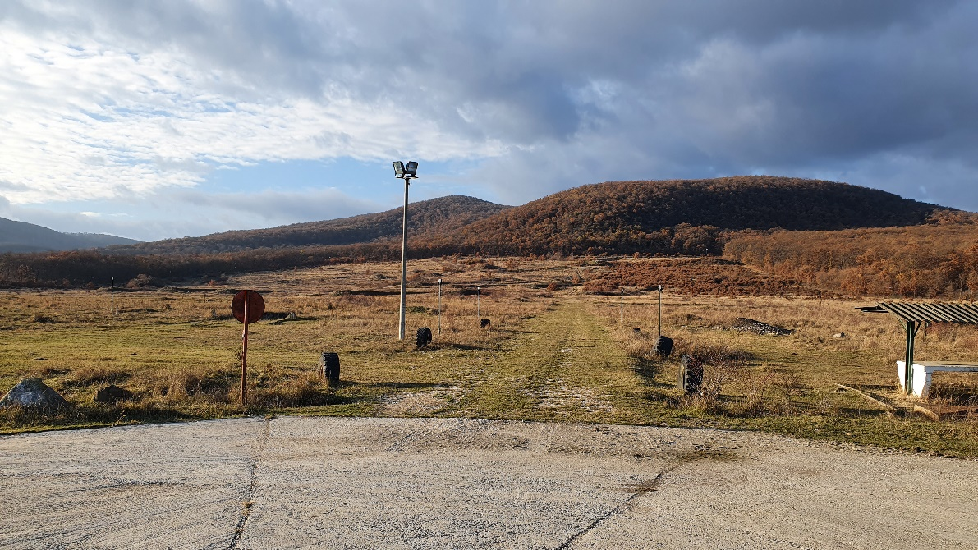
The shooting range is located only 5 km from the historic center of Szentendre (10-minute drive), and 23 km from the center of Budapest (30-minute drive).

Preliminary competition program
30-31st July 2022 - Arrival, firearms control
31st July 2022, Sunday, afternoon - Team captains meeting
31st July 2022, Sunday, evening - Welcome party
1st Aug 2022, Monday - 300 yards practice and competition (4-5 relays)
1st Aug 2022, Monday, evening - Opening ceremony
2nd Aug 2022, Tuesday - 500 yards practice and competition (4-5 relays)
3rd Aug 2022, Wednesday - 600 yards practice and competition (4-5 relays)
4th Aug 2022, Thursday - 900 yards practice and competition (4-5 relays)
5th Aug 2022, Friday - 1000 yards practice and competition (4-5 relays)
6th Aug 2022, Saturday, evening - Closing banquet, ceremonies

Protocol for using camera systems on MLAIC long range competitions
This document is based on the discussions and tests carried out with the MLAIC Long Range Committee, November-December, 2021.

Why digital camera system?
The ranges that currently fit for long range muzzle loading shooting are very few all across the World. As there is no breakeven point in carrying out such a huge work of building a shooting range with proper infrastructure, we decided to search for a working camera system. We already see its benefits: using the cameras allowed us to start LRML in Hungary, and now out of nothing we have today a team of 6 shooters reaching out to 900 yards. The method we developed with the LR Committee, we strongly believe will multiply the number of long range shooters all across the World, making this beautiful line of events accessible for many shooters. The camera system purchased by the Hungarian association for this purpose can serve the future MLAIC long range matches all across Europe.

How to integrate the use of digital camera system into the system of LRML?
- Basic principles:
  - The course of shotting must not be different for the shooters compared to shooting the traditional way
  - The record of information must be redundant: while we record digital information, we keep analogue information as well just in case of an IT breakdown. The information is kept digital AND on paper as well.
  - The match will be shot on 10 targets, an 11th target will be added to be used in case of camera malfunction.
- The system
  - Long Shot LR-3 camera and receiver system: https://www.longshotcameras.com/products/longshot-lr-3
  - Camera is placed 7 m from target, receiver is placed in the shooting position.
  - One receiver can handle 4 cameras
  - Use of external antenna is possible in case of bad signal (tested till 1km, and signal was 50-75% strength
  - 2 mile range
  - iOS and Android application are downloadable from the app store.
  - The application is capable of:
    - Digital zoom on the image to identify shots (8x)
    - Marking and numbering shots with different colours and numbers
    - Blinking function to show last shot
    - Recording video if necessary
    - Making a screenshot after each shot is helping solving claims
  - Sandbag protection seems perfect, we had still good signal at 1000y. This helps the quick relocation of the camera system.
  - Battery life: more than 9 hours - we tested it, and it is true even in freezing weather.
  - Camera resolution: UHD
- The squad at the shooting position
  - Duties of the line officer:
    - First duty of the line officer is to master the rules of LRML shooting.
    - Checking challenged shots during the relay by call on the screen.
    - Checking challenged shots at the target after the relay.
    - Signing scoring sheets after settling challenged shots.
    - A colleague from the arbitration committee may help and support the line officer so that we have 4 eyes principle
    - Any decision made at the physical target by the line officer is final.
    - There will be one line officer for each 5 targets.
  - Two shooters per target, differentiated by colour codes handled by the app of the LR-3 system. Both the bib number and both the scoring sheet of the shooter will be marked with the specific colour for easy identification while shooting.
  - Scorer with scoring sheets (one per shooter), and a screen, showing the mirror image of the monitor of the operator.
  - Scoring sheet data content:
    - Name of the shooter
    - Start number of the shooter
    - Class: R/O
    - Calibre and serial number of the rifle (if it has one)
    - Red / Blue colour indicator to easy the job of the operator and scorer
    - Table for sighter shots
    - Table for scored shots:
      - Number of shots
      - Value of shot
      - Sequence number of the shot provided by the application of the camera system
    - Picture of the target with spots indicating the position of shots marked with the sequence number
  - Operator with at least Full HD resolution tablet/monitor – clean the tablets after each relay. His role is to find and mark the shots for the scorer.
- The shooting procedure:
  - The course of fire is exactly the same as in the MLAIC LRML rulebook.
  - Shooters are differentiated by easy to distinguish colours (blue and red).
  - Red and blue sticker is placed on their scoring sheet and start number of the shooters just before the relay starts.
  - After a shot is fired the operator finds the shot, shows it to the shooter, they agree on the score, and the operator gives the information to the scorer by marking the shot with the colour of the shooter and sequence number. The operator signals the score to the scorer.
  - The scorer records the shot on the sheet: records the number in the table, and records the place of the shot on the drawing of the target and marks it with the sequence number. The officer in charge of the target does not allow the second competitor to take his/her shot until the first competitor's score has been agreed.
  - If there is no agreement, the line officer adds the necessary additional information to the specific shot: double shot, missing shot, cross shot.
  - When the relay is finished the image of the monitor of the application showing the different colour shots is saved for further use. (screenshot, showing the number of the relay and number of the line indicated on the target itself)
  - When relay is over the scoring sheets are signed by the shooters and are collected by the line officers and are given to the match director. The signature of the shooter should be made when all discrepancies have been clarified.
  - After the relay is finished the challenged shots are checked at each targets using calibre-sheet if necessary, by the line officer in charge of the specific target.
  - Result of the challenges are recorded on the scoring sheet. The scoring sheets are returned to the scoring office for further use.
  - After the relay is finished, each target is photographed with high resolution camera for further evidence and the images are handled to the match director for further use.
- The scoring
  - If there are no open challenges or claims on a target, and the shooter agrees, the score on the scoring sheet is definitive. The score card is signed by the scorer and the shooter.
  - If there are challenges or claims on the target, the final score is defined by the line officer after inspecting the target after the relay. The scoring sheet is amended by the result from the line officer. The shooter stays in his place before signing the scoring sheet. The scoring sheet is signed by the shooter, scorer and line officer. At this point the score is definitive.
  - Signed scoring sheets are double checked by the match director before publishing preliminary results. Preliminary results are published online.
  - Protest time ends at 9 o’clock in the morning of the following day. After the protests are settled final results are published on paper and online.
  - Claims are settled by the arbitration committee, based on the information from any necessary contributor, and on the available documents: scoring sheets, print screen of the app, digital photo of the target.
- Challenges:
  - Challenge of a missing shot:
    - If the operator and scorer does not find a shot on the screen, the shooter can place challenge for finding the shot (Message 5). This will be checked by the line officer right away at the screen. If the shot is still not found and the shooter is still sure about a hit, the shot will be marked on the scoring sheet and will be checked on the target by the line officer when the relay was over.
    - The decision is recorded on the scoring sheet, and it is final.
  - Challenge of the scoring value of a shot:
    - If the shooter and scorer does not agree on the value the line officer is called for double checking the shot on the screen.
    - If there is still disagreement, the shot is marked on the sheet for further inspection
    - Inspection is done after relay on the target by the line officer in charge of the specific target with using the paper scoring sheet.
    - Decision is recorded on the scoring sheet, and it is final.
    - Disputes will be settled at the targets, digital image of the target will not be used for further scoring.
  - Challenge of a double shot (multiply shots impacting the same hole):
    - If the shooter and scorer does not agree on a double shot the line officer is called for double checking the shots on the screen.
    - If there is still disagreement, the supposed double shot is marked on the sheet for further inspection.
    - Inspection is done after relay on the target by the line officer in charge of the specific target with using the paper scoring sheet.
    - Decision is recorded on the scoring sheet, and it is final.
  - Challenge of cross shots:
    - If the shooter, scorer or operator reports a cross shot, the line officer is called for double checking the shot on the screen.
    - The shooter gets the higher score.
    - The shot is marked by the operator with yellow, and the sequence number is recorded on the scoring sheet by the scorer indication it is a cross shot.
    - Decision is recorded on the scoring sheet, and it is final.
    - Communication with the neighbouring scorer is possible in order to find a solution fast.
  - Scoring a ricochet with multiple holes:
    - If the shooter, scorer or operator reports a ricochet shot with multiple impacts, the line officer is called.
    - The line officer checks the shots on the screen, and selects the highest value for the shooter.
    - The operator marks the selected highest value impact with the colour of the shooter, and marks the other impacts with yellow.
    - The scorer records the sequence number of the highest value impact on the scoring sheet with the value, and records the discarded impacts and their sequence numbers on the scoring sheet indicating that they are caused by ricocheting bullets.
    - Decision is recorded on the scoring sheet, and it is final.

Important safety rules
1 No firearms to be taken onto the firing point without the permission of the Range Officer.
2 All shooters are responsible for ensuring that all firearms and ammunition intended to be used are safe to use.
3 Hearing and eye protection are mandatory.
4 Firearms must be carried muzzle up when moving between the loading area and firing point.
5 People may be shooting in front (echelon shooting) either to our left or right, your rifle must be turned at the direction of the target at all times when shooting or adjusting the rifle sights. Adjusting sights is only allowed if the rifle is unloaded.
6 Rifles can only be capped when pointing at your target. Only bring the rifle in full cock when you are intending to fire and you are pointing the rifle at the target.
7 It is strictly forbidden to handle powder flasks in the loading or firing line. Powder must be poured into the barrel from vials.
8 In case of misfire wait 30 seconds with the rifle pointing on the target, if assistance is required raise your hand and notify the Range Officer.
9 All malfunctions must be cleared on the firing point and not brought back to the loading area.
10 All fouling/warming shots and miss loads must be fired from the prone or back position into the bullet stop.
11 In case of emergency cease fire the arms must remain pointed towards the target and the percussion caps must be removed from the nipples in this status. Then the rifles are to be laid on the ground with hammers in half cock position (if the rifle does not have a half cock position, the hammer must rest on the uncapped nipple). The shooters will then set back from the firing line. Those waiting to shoot will return to the loading area with the barrel of the rifle pointing up.

Travel and accommodation information
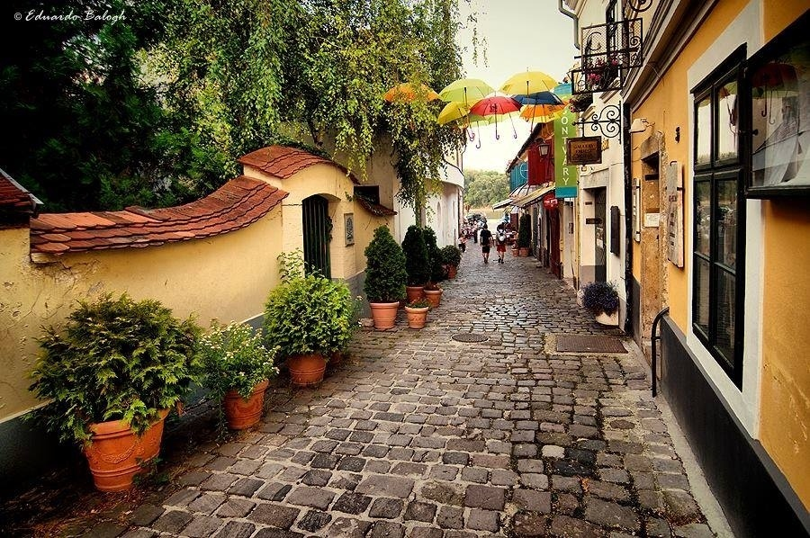
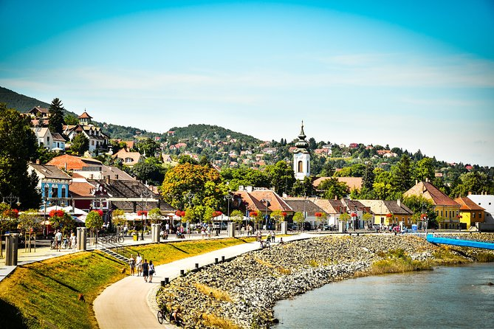
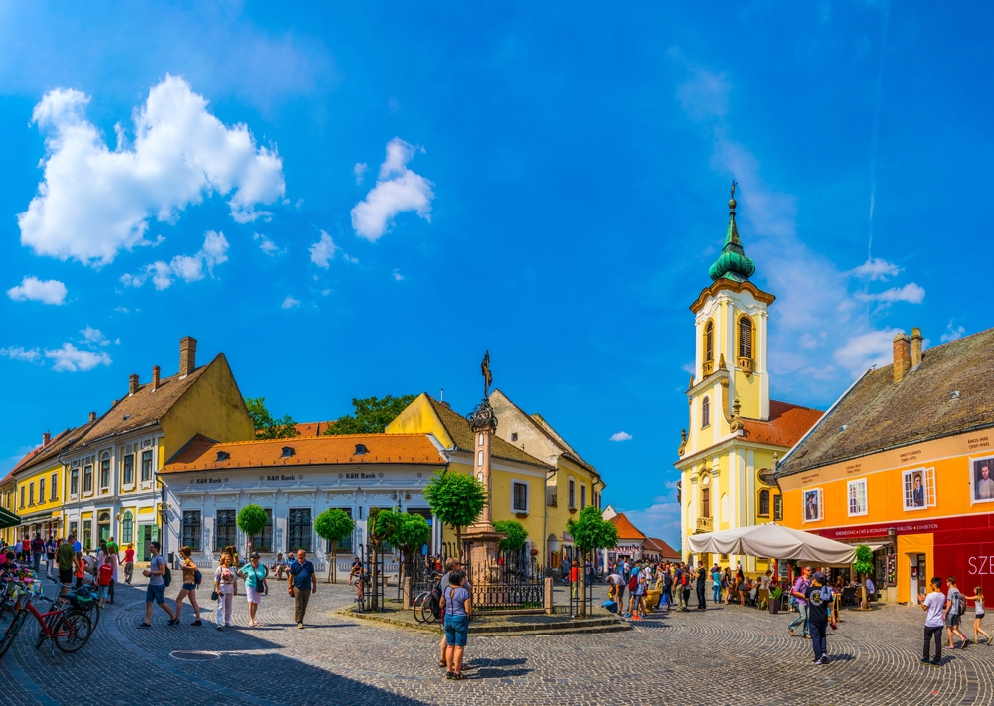
Szentendre is a riverside town in Pest County, Hungary, between the capital city Budapest and Pilis-Visegrád Mountains. The town is known for its museums (most notably the Open-Air Ethnographic Museum), galleries, and artists. Due to its historic architecture and easy rail and river access, it has become a destination for tourists staying in Budapest. There are many facilities, including souvenir shops and restaurants, catering to these visitors. Szentendre has been the home of generations of Hungarian artists since the early 20th century. Szentendre Artists' Colony worked in the northern part of the town. There are many museums and contemporary galleries representing the rich traditions of the visual art. Szentendre is best known for its Mediterranean vibes, Baroque architecture, history of Serbian residents, Hungarian folklore stores, and extensive art scene, both old and modern.
About Szentendre on Tripadvisor:
https://www.tripadvisor.com/Tourism-g274914-Szentendre_Pest_County_Central_Hungary-Vacations.html
About Szentendre on Budapest.com:
https://www.budapest.com/hungary/cities/szentendre.en.html

