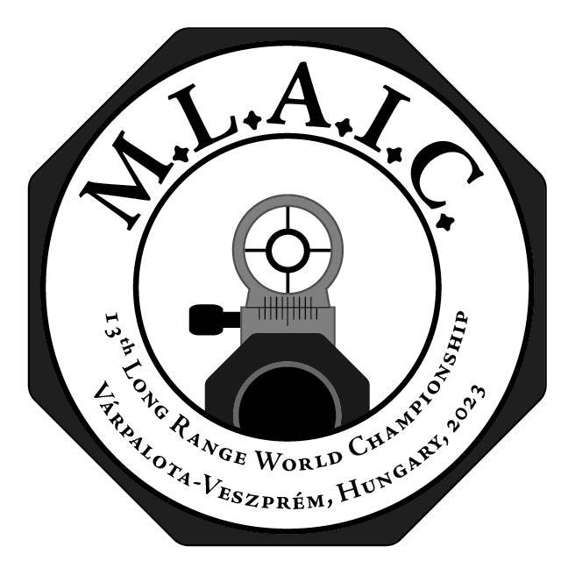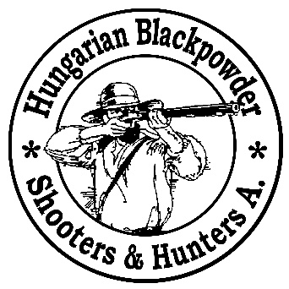

Information booklet of the 13th MLAIC World Championships
27th August – 2nd September 2023
Várpalota-Veszprém, Hungary
Version: 2023.02.12.
Table of contents
Official Invitation to the 13th MLAIC Long Range World Championships 2
General information about the 13th MLAIC World Championships 3
Location: 3
Information about firearms laws in Hungary: 3
Disciplines: 3
Target sizes: 4
The camera system: 4
Maximum number of shooters: 4
Categories: 4
Costs: 4
The organizing committee: 5
Registration information and dates 5
Deadlines 5
Bank data of the Hungarian Blackpowder Shooters and Hunters Association: 6
Shooting range information 6
Preliminary competition program 6
Important safety rules 7
Accommodation 7

Official Invitation to the 13th MLAIC Long Range World Championships

Dear Delegates, Team Captains, dear Long Range Shooters of the World,
On behalf of Hungarian Blackpowder Shooters and Hunters Association and the Muzzleloaders Associations International Confederation, it is our pleasure to extend the invitation to the 13th MLAIC Long Range World Championships from 27th August – 2nd September 2023, Várpalota-Veszprém, Hungary.
The event will take place close to the Lake Balaton, on a military range. This location not only serves the competition well, but also offers an excellent possibility for shooters and family members to immerse in the beauty and history of our little central European country.
Official web-page of the event: https://mlaic.org
Facebook page of the event: https://www.facebook.com/MLAICChamps
Official email of the event: registration@meflsz.hu
Location: Hungary, Várpalota-Veszprém
It would be our honor to have your national team's presence on this auspicious occasion.
We do hope that you will be able to confirm your attendance to this invitation; we look forward to your presence at this celebration of historical shooting sports.
If you have any questions, please do not hesitate to contact us.
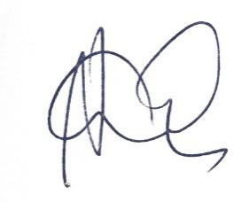
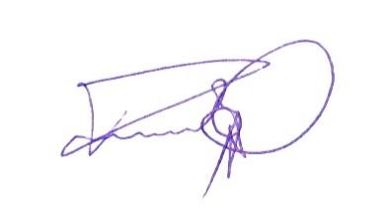
See you in Hungary!
Yours Sincerely,

Pál Törőcsik Balázs Németh
Chairman Head of the organizing committee

General information about the 13th MLAIC World Championships

Location:
The competition will be shot at the military shooting range located between the cities of Várpalota and Veszprém. The range is located at a distance of 20-minute drive from the beautiful lake Balaton, and 90-minute drive from the center of Budapest.
Google maps location: https://goo.gl/maps/ZTPKv6YhNKuahTDv5

Information about firearms laws in Hungary:
All muzzle loading arms are free in Hungary, and they are free for private import as well. Therefore, no license is needed to enter the country with muzzle loading arms. However, to ease customs procedures for participants arriving by plane, the individual entry forms will be returned to the competitors signed by our association. We will also notify the customs offices at the Liszt Ferenc Budapest Airport about the arrival of the national teams.
Black powder and percussion caps are licensed in Hungary. They can only be purchased by licensed personnel; they cannot be imported into the country by private persons. The powder and caps ordered by the national teams will be handed over by the Hungarian organization to the teams at the shooting range upon arrival.

Disciplines:
All disciplines will be shot on the yard system. Team events will be shot separately. Both original and replica class will be held during the World Championships. One shooter can register in either replica or original class. All disciplines will be shot on digital long range camera systems with the ruling developed in accordance with the LR Committee and accepted on the MLAIC delegates meeting of 2022.

Target sizes:
The competition will be shot on yard basis, using the corresponding target sizes. The only difference will be on 900 and 1000 yards, where the total height of the target will be 60” instead of 70” due to the field of view of the camera system. All other parameters of the targets will be as they are described in the MLAIC Rule Book 7.9 section.

The camera system:
The camera system used for the competition will be the Long Shot LR-3 system. The scores will be convenient to follow on any iOS or Android tablet or smart phone. Tablets will be provided by the HBSHA to the scorers, but we suggest the shooters to bring their smart phones/tablets as well, as they will have access to the WLAN system of the cameras. We also suggest to equip power banks for the smart phones and tablets. The protocol of using the camera system will be the same as used in Hungary 2022, refined and accepted by the LR Committee.

Maximum number of shooters:
The maximum shooters to participate on the match is 100 persons. Each country is allowed to enter a maximum of 10 shooters for the competition. In case of significantly less or more individual registrations, the HBSHA will reconsider the maximum registration limit according to actual numbers.

Categories:
We organize the full MLAIC World Championships long range program for individual O and R shooters, and national teams shot separately. As a side match we also organize black powder cartridge match with the same rules, same distances. Please note that it is not possible to shoot both muzzle loading and breech loading classes simultaneously. BPCR shooters are to follow these rules:
- All single shot pre 1896 rifles are allowed unless the cartridge is loaded with black powder
- Any positions are allowed, the rifle can be supported at one point (cross sticks or sandbag)
- When arriving from an EU country you must have a European Firearms Passport for your rifle
- When arriving with a breech loading rifle from outside the EU, you must apply for an import license from Hungary. In this case, please contact us: registration@meflsz.hu
- For BPCR class only traditional diopter sights are allowed, optical sights not
- In all other questions, MLAIC LR rules apply

Costs:
Individual registration: 550 EUR, that covers the sandwich and refreshment bags for each competition days and also the welcome party organized by the HBSHA.
Team registration: Team registration is 80 EUR/team/country
Closing banquet: 80 EUR / person
Black powder and caps:
***
Please note that due to the current shortage of percussion caps, the cost of powder and caps can change until the start of the competition. The prices shown below are just for indication.
***
Swiss black powder: 110 EUR / kg.
RWS small caps: 30 EUR / box of 250 pcs, RWS small caps +: 32 EUR / box of 250
RWS large caps: 32 EUR / box of 200 pcs

The organizing committee:
Official email address of the comp.: registration@meflsz.hu
Match director: Gerda Lejeune,
Head of Arbitration Committee: to be discussed later
Arbitration Committee: to be discussed later
Head of organizing committee: Balázs Németh
Members of the organizing committee: Pál Törőcsik
Szilárd Venczel
Sándor Pólik
Roland Országh
Kornél Országh
Lajos Meszesi
Ágnes Tóth
Firearms Control Inspectors: to be discussed later
Chief Range Officer: Pál Törőcsik
Line Officer: to be discussed later

Registration information and dates
Questions about registrations: registration@meflsz.hu
***
We accept only digital registrations using the following link:
***
Individual registration form to be filled by the shooters until 1st May 2023:
https://meflsz.hu/mlaic-long-range-world-cup-2023-individual-registration/
National registration form to be filled by the team captain until 28th February 2023:
https://meflsz.hu/mlaic-long-range-world-championship-2023-hungary-national-entry-form/
Please note that all individual registrations shall be approved by the national organization of the shooter. In case of BPCR registration, these criteria are not applied.

Deadlines
28st Feb 2023 - Return of powder and caps order form. Please note that we must have a proper indication of the qty of powder and caps till this date. If we do not receive information till this day, we will not be able to provide caps and powder to the team.
28th Feb 2023 - Return of national registration forms
1st May 2023 - Return of individual registration forms
15th May 2023 - Final deadline for transferring registration fees and cost of powder and caps
31st May 2023 - Last date of possible full refund
1st – 30th June 2023 - Last period for 50% refund
30th June 2023 - After this date refund is not possible
31th July 2023 - Last date for possible amendments of the registration

Bank data of the Hungarian Blackpowder Shooters and Hunters Association:
Beneficiary: Hungarian Blackpowder Shooters and Hunters Association
Address: 1044 Budapest, Kálvin János u. 35. HUNGARY
Bank: OTP Bank, Hungary
Bank address: 1051 Budapest, Nádor utca 16. HUNGARY
IBAN: HU87 117040072019923600000000
BIC/Swift: OTPVHUHB

Shooting range information
Orientation of the range: shooting from South to North.
The area behind and before the targets will be cleared from vegetation so the impact of shots missing the target will be visible. The distance between targets will be 3 m. Targets will be marked with large enough numbers in white, black and red to ease quick identification.
The shooting range is situated between Várpalota and Veszprém, and 90-minute drive from Budapest.

Preliminary competition program
27th Aug 2023, Sunday - Arrival, firearms control from 14:00
27th Aug 2023, Sunday, afternoon - Team captains meeting from 16:00
27th Aug 2023, Sunday, evening - Welcome party from 19:00
28th Aug 2023, Monday - 300 yards practice and competition
28th Aug 2023, Monday, evening - Opening ceremony from 20:00
29th Aug 2023, Tuesday - 500 yards practice and competition
30th Aug 2023, Wednesday - 600 yards practice and competition
31st Aug 2023, Thursday - 900 yards practice and competition
1st Sept 2023, Friday - 1000 yards practice and competition
2nd Sept 2023, Saturday - Team events if necessary, closing banquet, ceremonies

Important safety rules
1 No firearms to be taken onto the firing point without the permission of the Range Officer.
2 All shooters are responsible for ensuring that all firearms and ammunition intended to be used are safe to use.
3 Hearing and eye protection are mandatory.
4 Firearms must be carried muzzle up when moving between the loading area and firing point.
5 People may be shooting in front (echelon shooting) either to our left or right, your rifle must be turned at the direction of the target at all times when shooting or adjusting the rifle sights. Adjusting sights is only allowed if the rifle is unloaded.
6 Rifles can only be capped when pointing at your target. Only bring the rifle in full cock when you are intending to fire and you are pointing the rifle at the target.
7 It is strictly forbidden to handle powder flasks in the loading or firing line. Powder must be poured into the barrel from vials.
8 In case of misfire wait 30 seconds with the rifle pointing on the target, if assistance is required raise your hand and notify the Range Officer.
9 All malfunctions must be cleared on the firing point and not brought back to the loading area.
10 All fouling/warming shots and miss loads must be fired from the prone or back position into the bullet stop.
11 In case of emergency cease fire the arms must remain pointed towards the target and the percussion caps must be removed from the nipples in this status. Then the rifles are to be laid on the ground with hammers in half cock position (if the rifle does not have a half cock position, the hammer must rest on the uncapped nipple). The shooters will then set back from the firing line. Those waiting to shoot will return to the loading area with the barrel of the rifle pointing up.

Accommodation
if you request help with accommodation, please contact Ágnes Tóth: tothagi519@gmail.com

